# Empowering The Future: A Literacy Rate Analysis For A Better Future Tomorrow (Only For Engg)

To know development in a society, Literacy is another proper indicator of economic development. For purpose of census, a person in age limit of seven and above, who can both write and read with understanding in any of the language is considered as a literate in India. Literacy plays a major role in the economic development of a nation. Although India has raised its current literacy rate of 74.04% (2021) from 12% at the time of Independence in 1947, its still lag behind the world average literacy rate of 84%. Compared with other nations, Republic of India has the largest illiterate population.

|  |  |
| --- | --- |
| India Literacy Rate (According to 2011 Census) | |
| Overall | 74.04% |
| Male | 82.14% |
| Female | 65.46% |

Majority of states in India has shown majors signs of improvement in their overall illiteracy rate thus contributing towards a literate nation

Here we are analysing literacy rate in India for 2021. This dataset contains a record Literacy rate each states of India, here we are going to analyse State wise, Region wise and Overall Literacy rate among Children, Women and Men in India in India.

**Technical Architecture:**

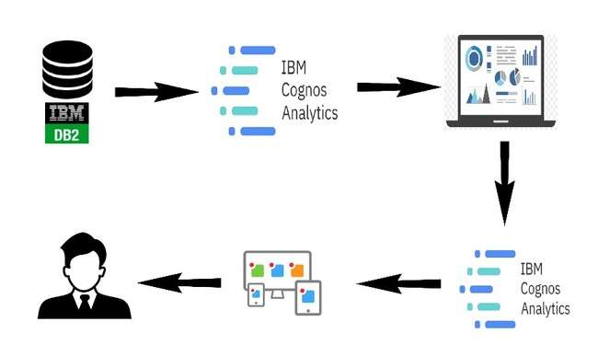

# Project Flow

To accomplish this, we have to complete all the activities listed below,

* Define Problem / Problem Understanding
  1. Specify the business problem

○ Business requirements

○ Literature Survey

○ Social or Business Impact.

* Data Collection & Extraction from Database
  1. Collect the dataset,

○ Connect IBM DB2 with IBM cognos

* Data Preparation
  1. Prepare the Data for Visualization ● Data Visualizations

○ No of Unique Visualizations ● Dashboard

○ Responsive and Design of Dashboard ● Story

○ No of Scenes of Story

* Report
  1. Creating a report ● Performance Testing

○ Amount of Data Rendered to DB ‘

○ Utilization of Data Filters

○ No of Calculation Fields

○ No of Visualizations/ Graphs ● Web Integration

○ Dashboard and Story embed with UI With Flask

* Project Demonstration & Documentation
* Record explanation Video for project end to end solution
* Project Documentation-Step by step project development procedure

# Define Problem / Problem Understanding

A problem statement is a clear and concise description of the issue or challenge that needs to be addressed. It should define the problem in a way that is understandable to stakeholders and provide a basis for developing a solution or course of action.

# Business Requirements

Understanding the literacy rate in India can also help businesses keep track of government policies and initiatives aimed at improving literacy rates. Businesses need to understand the literacy rates in India to conduct market research and determine the potential customer base for their products or services. The literacy rate analysis in India can help businesses make informed decisions, improve their marketing efforts, plan their workforce, and contribute to social causes, among other benefits. The ultimate goal is to gain insights and improve performance through data visualization techniques.

# Literature Survey (Student Will Write)

A literature survey for Literacy Rate Analysis involves reviewing academic articles, and other sources related to the analytics of Literacy Rate. Literacy rate analysis in India has been a topic of interest for researchers, policymakers, and scholars for many years. A literature survey on this topic reveals a wealth of information about the factors that influence literacy rates in India, as well as the challenges faced by policymakers in improving literacy rates across the country

**Social Or Business Impact.**

Social Impact: It have a significant social impact, including the empowerment of individuals, improved social inclusion, poverty reduction, improved health outcomes, and promotion of gender equality

Business Model/Impact: It have a Businesses that invest in literacy programs and support education initiatives can benefit from a more skilled and innovative workforce, improved competitiveness, and enhanced social responsibility.

# Data Collection & Extraction From Database

Data collection is the process of gathering and measuring information on variables of interest, in an established systematic fashion that enables one to answer stated research questions, test hypotheses, and evaluate outcomes and generate insights from the data.

# Collect The Dataset

Please use the link to download the dataset: [Link](https://drive.google.com/file/d/1j7--V-Bw_1bFE1cC2Ci79OR9yip7JsXW/view?usp=sharing)

**Understand the data**

Data contains all the meta information regarding the columns described in the CSV files. The name of file is India_Updated Literacy 2021.csv

Description for India_Updated Literacy 2021.csv:

The file India_Updated Literacy 2021.csv contains 112 rows. Each row corresponds to record of state with details and marks in respective subjects. The columns are:

Columns are:

* States- Indian States
* Area- Rural or Urban Area
* Children age 5 years who attended pre-primary school
* Women (age 15-49) (%)
* Men (age 15-49) (%)
* Women (age 15-49) with 10 or more years of schooling (%)
* Men (age 15-49) with 10 or more years of schooling (%)

**Data Preparation**

In this milestone, we will see how to prepare the data for building visualizations

# Prepare The Data For Visualization

Data modules are containers that describe data and rules for combining and shaping data to prepare it for analysis and visualization in IBM Cognos Analytics. Data module sources. Data modules can be based on data servers, packages, uploaded files, data sets, and other data modules

● Prepare a Data Module

# Data Visualization

Data visualization is the process of creating graphical representations of data in order to help people understand and explore the information. The goal of data visualization is to make complex data sets more accessible, intuitive, and easier to interpret. By using visual elements such as charts, graphs, and maps, data visualizations can help people quickly identify patterns, trends, and outliers in the data.

# Dashboard

A dashboard is a graphical user interface (GUI) that displays information and data in an organized, easy-to-read format. Dashboards are often used to provide real-time monitoring and analysis of data, and are typically designed for a specific purpose or use case. Dashboards can be used in a variety of settings, such as business, finance, manufacturing, healthcare, and many other industries. They can be used to track key performance indicators (KPIs), monitor performance metrics, and display data in the form of charts, graphs, and tables.

# Responsive And Design Of Dashboard

The responsiveness and design of a dashboard for Data-Driven insights on Literacy rate is crucial to ensure that the information is easily understandable and actionable. Key considerations for designing a responsive and effective dashboard include user-cantered design, clear and concise information, interactivity, data-driven approach, accessibility, customization, and security. The goal is to create a dashboard that is user-friendly, interactive, and data-driven, providing actionable insights.

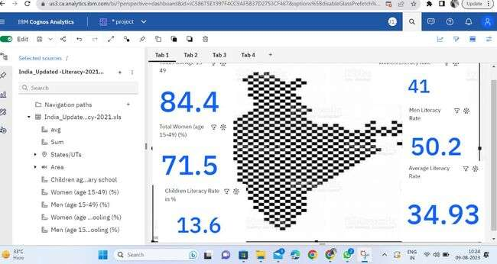

# Story

A data story is a way of presenting data and analysis in a narrative format, with the goal of making the information more engaging and easier to understand. A data story typically includes a clear introduction that sets the stage and explains the context for the data, a body that presents the data and analysis in a logical and systematic way, and a conclusion that summarizes the key findings and highlights their implications. Data stories can be told using a variety of mediums, such as reports, presentations, interactive visualizations, and videos.

https://us1.ca.analytics.ibm.com/bi/?perspective=story&pathRef=.my_folders%2FLiteracy%2Brate%2 Bstory&action=view&sceneId=model00000189b5382921_00000000&sceneTime=0

# No Of Scenes Of Story

The number of scenes in a storyboard for Data-Driven insights on Literacy will depend on the complexity of the analysis and the specific insights that are trying to be conveyed. A storyboard is a visual representation of the data analysis process and it breaks down the analysis into a series of steps or scenes.

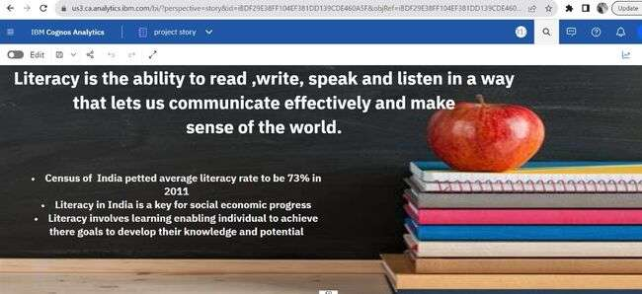

[https://us1.ca.analytics.ibm.com/bi/?perspective=story&pathRef=.my_folders%2FLiteracy%2](https://us1.ca.analytics.ibm.com/bi/?perspective=story&pathRef=.my_folders%2FLiteracy%2Brate%2Bstory&action=view&sceneId=model00000189b51fd07f_00000002&sceneTime=0)

[Brate%2Bstory&action=view&sceneId=model00000189b51fd07f_00](https://us1.ca.analytics.ibm.com/bi/?perspective=story&pathRef=.my_folders%2FLiteracy%2Brate%2Bstory&action=view&sceneId=model00000189b51fd07f_00000002&sceneTime=0)

A report in data analytics typically involves analysing and interpreting data to draw insights and conclusions that can inform business decisions or address research questions. The report usually includes a summary of the data analysis process, including the methods and tools used, as well as the findings and recommendations based on the analysis. The report should begin with an executive summary, which provides a brief overview of the main findings and recommendations. The introduction should provide background information on the problem or research question being addressed and the data sources used.

[https://us1.ca.analytics.ibm.com/bi/?perspective=story&pathRef=.my_folders%2FLiteracy%2Brate%2](https://us1.ca.analytics.ibm.com/bi/?perspective=story&pathRef=.my_folders%2FLiteracy%2Brate%2Bstory&action=view&sceneId=model00000189b54122ad_00000000&sceneTime=3150)

[Bstory&action=view&sceneId=model00000189b54122ad_00000000&sceneTime=3150](https://us1.ca.analytics.ibm.com/bi/?perspective=story&pathRef=.my_folders%2FLiteracy%2Brate%2Bstory&action=view&sceneId=model00000189b54122ad_00000000&sceneTime=3150)

# Creating Report

When creating a report in Cognos, it is often helpful to include visualizations to help communicate the findings of the analysis.

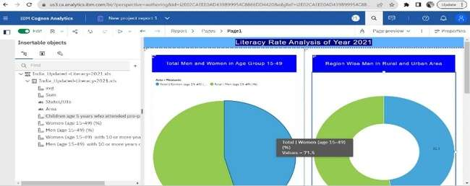

**Performance Testing**

# Utilization Of Filters

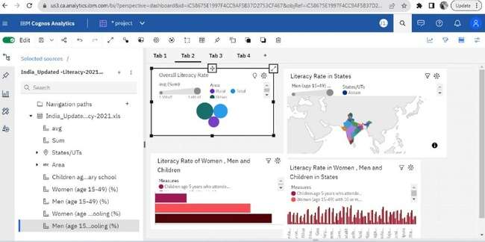

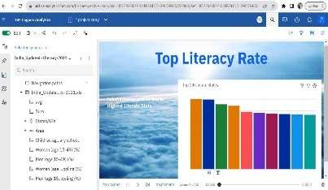

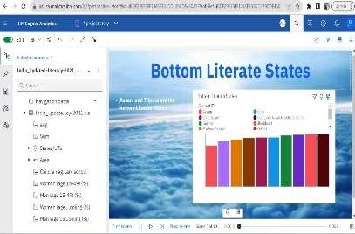

# No Of Calculation Fields

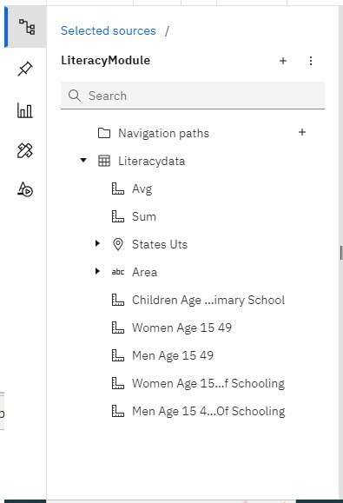

# No Of Visualizations/ Graphs

* Overall Literacy Rate
* Literacy Rate in Indian States
* Literacy Rate of Women, Men and Children
* Average Literacy Rate of Women, Men and Children in States
* Top Literate States
* Bottom Literate States
* Women Literacy Rate in Rural and Urban Area
* Men with Age group 15-49 over those who attended schooling

# Web Integration

Publishing helps us to track and monitor key performance metrics, to communicate results and progress. help a publisher stay informed, make better decisions, and communicate their performance to others.

Step: Go to Dashboard, report & /story, click on share button on the top.

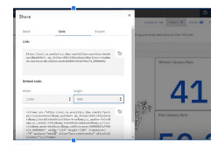

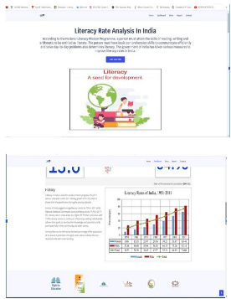

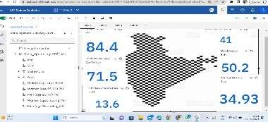



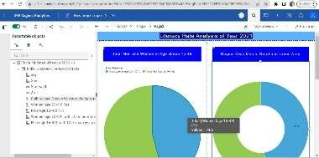

# Dashboard And Story Embed With UI With Flask

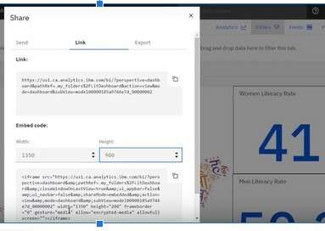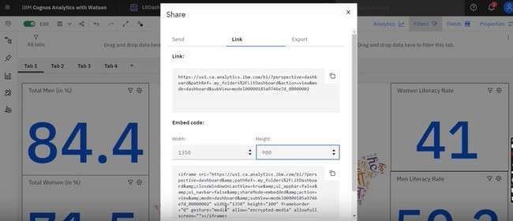

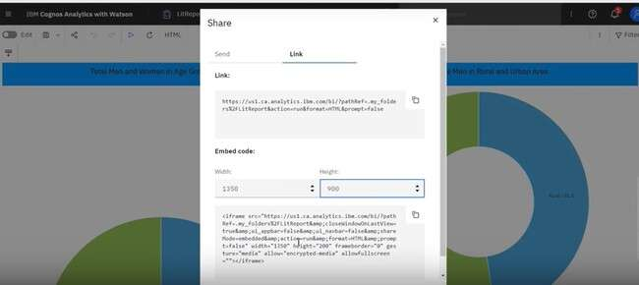

# Project Demonstration & Documentation

Below mentioned deliverables to be submitted along with other deliverables

Activity 1:- Record explanation Video for project end to end solution

Activity 2:- Project Documentation-Step by step project development procedure

Create document as per the template provided